VEX V5 Override: Session 2 - Virtual Coding Station

Activity: Code Flex to score points in V5 Override Virtual Coding Skills!

- Go to vrskills.vex.com and select ‘autonomous coding skills’, or open VEXcode VR. Select the V5 Override 26-27 Playground.
  - You need your team’s Number and Virtual Skills Key from your Coach in order to access the Playground.
- Make a plan for how you will score points with Flex.
  - Robot Skills has some slightly different rules and scoring. Review those differences and similarities in Section 3 of the game manual.
  - Use tools like images of the Field to help you plan and document your path for the robot when coding Flex.

- Code Flex to score as many points as you can in 60 seconds!
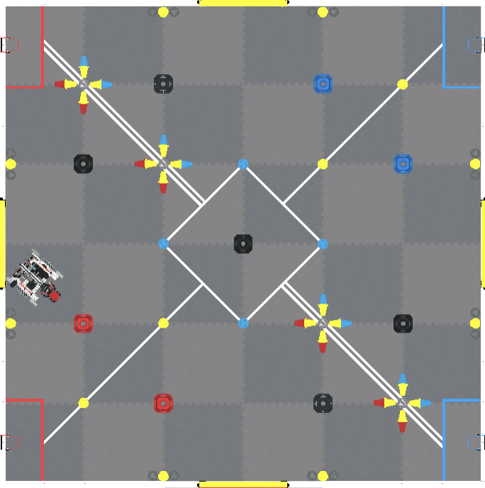
Example Documentation:

Coding Steps:

Feeling Stuck?
- Remember that you can find more information about the Playground, Flex, and how to code in Virtual Skills at api.vex.com.

Discussion Questions  - How does your experience with Virtual Driving Skills Practice impact your plans for this activity?  - What do you think is the most efficient path for Flex to score points? Why?  - How are you deciding what blocks to use when coding? | Activity Checklist  - Each team member read the Robot Skills section of the manual.  - Each team member documented a plan for their code.  - Each team member took a turn coding Flex.

